# Install the tSQLt build

## Clone Git Repository to local directory

* For manual download: <https://github.com/tSQLt-org/tSQLt>
* Git
  1. Create or locate directory for repository
  2. Execute (CMD.EXE)
     1. CD [that directory]
     2. git clone <https://github.com/tSQLt-org/tSQLt.git>
  3. This creates a tSQLt directory in that place. Later references to .\tSQLt\ in this document refer to that location

## Setup instance alias (optional)

1. Enable TCP connections on instance (see Google)
2. Create Dev_tSQLt Alias  
   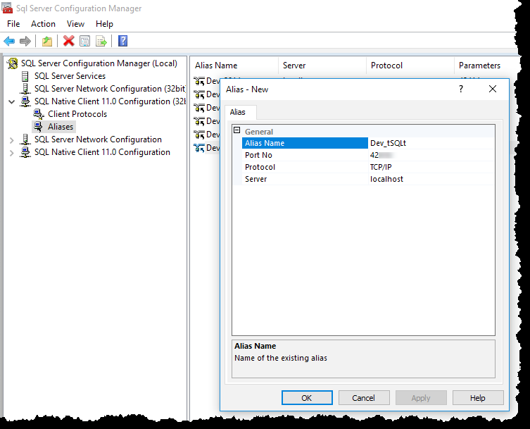

## Create Logins

1. Execute (CMD.EXE):
   1. CD .\tSQLt\Build
   2. Setup.bat tSQLt_Dev

## Install NANT

1. Download NANT from <http://nant.sourceforge.net/>
   1. (likely at <https://sourceforge.net/projects/nant/files/nant/0.92/>)
2. Unzip to folder on C: (not under C:\Users)

## Set Environment Variables

1. Open File Explorer window
2. Click on the Path Bar (behind the current path, not on)  
   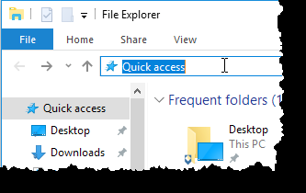
3. Type in Control Panel\System and Security\System
4. Hit <Return>
5. Select [Advanced system settings]  
   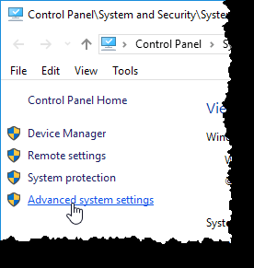
6. Click on [Environment Variables…] button  
   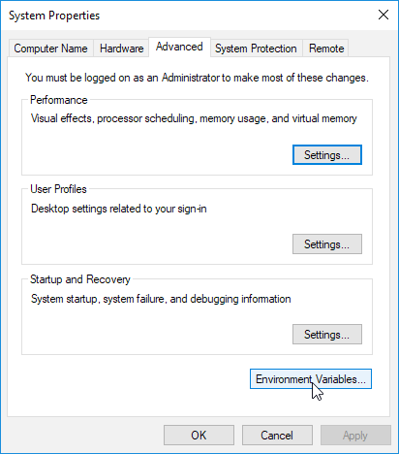
7. Create 2 new System variables ( NAntHome & NET4Home )  
   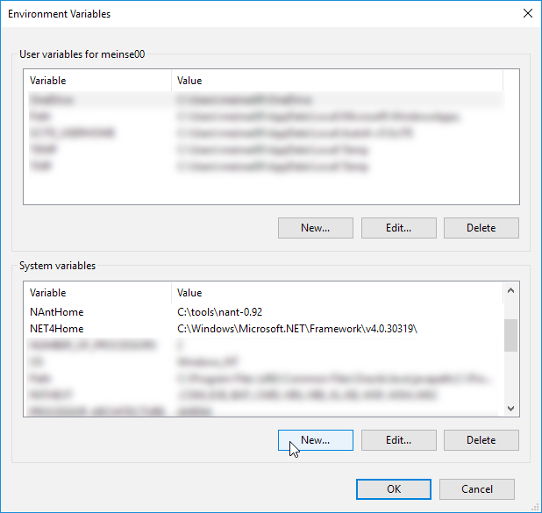
   1. Set the paths according to where NANT and .NET 4.0 are installed!

## Create SSMS Tool & Shortcut

1. Open SSMS
2. Menu / Tools / Options  
   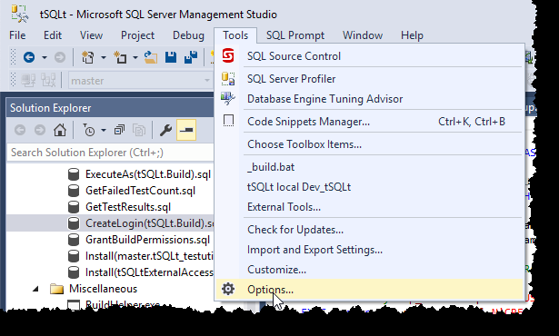
3. Query Shortcuts  
   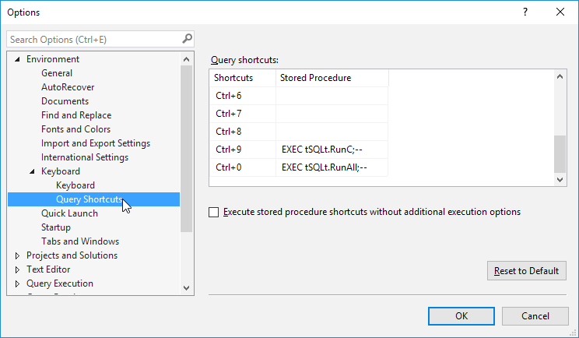
4. Enter these shortcuts (Exactly as typed here!)

|  |  |
| --- | --- |
| Ctrl+9 | EXEC tSQLt.RunC;-- |
| Ctrl-0 | EXEC tSQLt.RunAll;-- |

1. Menu / Tools / External Tools  
   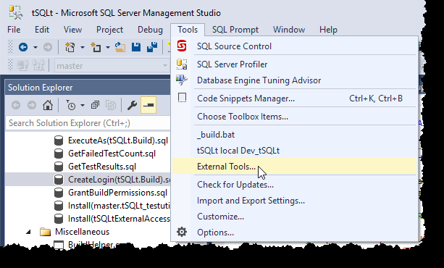
2. Click [ADD] button  
   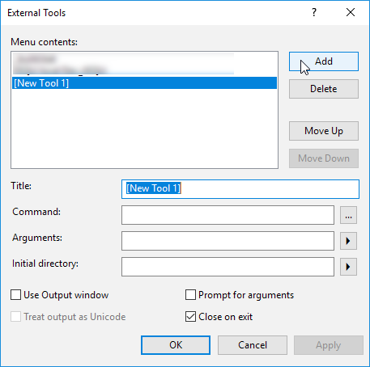
3. Type in the information below:  
   (The last three items in the Arguments box are: SQL Server version, Instance, Database. The version is important, because tSQLt has different tests for different versions.)

|  |  |
| --- | --- |
| Title | tSQLt local Dev_tSQLt |
| Command | $(SolutionDir)\Build\localNBuild.bat |
| Arguments | %NAntHome% %Net4Home% 2016 Dev_tSQLt tSQLt_dev |
| Initial directory | $(SolutionDir)\Build |

## Run the build

1. Open SSMS
2. Open the tSQLt solution in .\tSQLt \tSQLt.ssmssln
3. Connect Object Explorer to the Dev_tSQLt instance
4. Menu / Tools / tSQLt local Dev_tSQLt  
   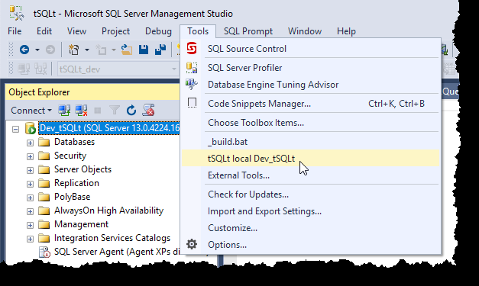
5. Confirm Build Succeeded